INTRODUCTION

The Computer and Accessories Sales Management System is developed to efficiently manage customer information, product inventory, and sales records. The system, implemented in Python with MySQL integration, aims to streamline operations in a computer and accessories retail environment. This project involves creating and managing relational tables (Customer, Products, Sales) in MySQL, with operations facilitated through a Python interface.

OBJECTIVES

- Database Connection and Setup:-
- Establishes a connection to the MySQL database with the sqltor.connect() function, ensuring all interactions are logged securely.
- Sets up the database tables (Customer, Products, Sales) with defined primary keys and foreign key relationships for efficient data storage and retrieval.

- Customer Management:-
- insert_customer() : Adds new customers to the `Customer` table, capturing details like `Name`, `Contact`, and `Address`. This function also checks for duplicate contacts to avoid redundancy.
- update_customer(new_value, cont) : Updates existing customer details such as `Name`, `Contact`, or `Address` based on their contact number, ensuring data remains current.
- delete_customer(cont): Deletes a customer record using the contact number, supporting data maintenance and cleanup.
- view_customer(): Retrieves and displays all customer records in a tabular format, improving data accessibility and readability.
- check_customer_exists(cont): Verifies if a customer exists based on their contact number before a sale, allowing seamless addition of new customers when needed.

- Product Management :
- insprod() : Adds new products to the `Products` table, including details like `Category`, `Name`, `Specifications`, `Stock`, and `Price`. This function helps keep track of all available products.
- delprod(pid) : Deletes a product based on its `P_ID` (Product ID), aiding in inventory management by removing discontinued items.
- Product Update Options : Provides a menu-driven interface to:
- Update product name.
- Update product specifications.
- Update product stock by adding new stock to the existing value.
- Update product price.
- view_products() : Displays all product records, presenting details in an organized table.
- category_view() : Displays products filtered by their category, allowing easy viewing of items within a specific group (e.g., Laptops, Desktops).
- search_by_product_name() : Searches products by name, displaying detailed information if found, or prompting for addition if not found.

- Sales Management :
- check_product_stock(p_id, quantity) : Verifies if a sufficient quantity of a product is available before processing a sale, helping prevent stock inconsistencies.
- view_sales() : Displays all sales transactions with details like `Customer Name`, `Product ID`, `Quantity`, `Total Amount`, and more.

- Sales Processing :
- Sale Entry : During a sale, the system checks for customer existence, verifies product availability, and calculates the total amount.
- make_sale(): (incorporated in the main loop) Records the sale in the `Sales` table and updates the product stock, ensuring accuracy in both sales records and inventory.
- Customer Purchase History : Provides the option to view purchase history for a particular customer, enabling customer relationship management and personalized service.

- Interactive Menu System :
- The main program runs a menu-driven interface for navigating between functions, making it intuitive for users to select and perform operations.
- Options include inserting, updating, and viewing records, managing stock, viewing sales, and exiting the system gracefully.

HARDWARE AND SOFTWARE REQUIREMENTS

Hardware :-
- Desktop Computer /Laptop
- Mobile phone

Software :-
- Python (latest version)
- MySQL
- MySQL-Connector-Python, Requests, Wikipedia-API, Datetime, Pyfiglet Modules

FLOW CHART

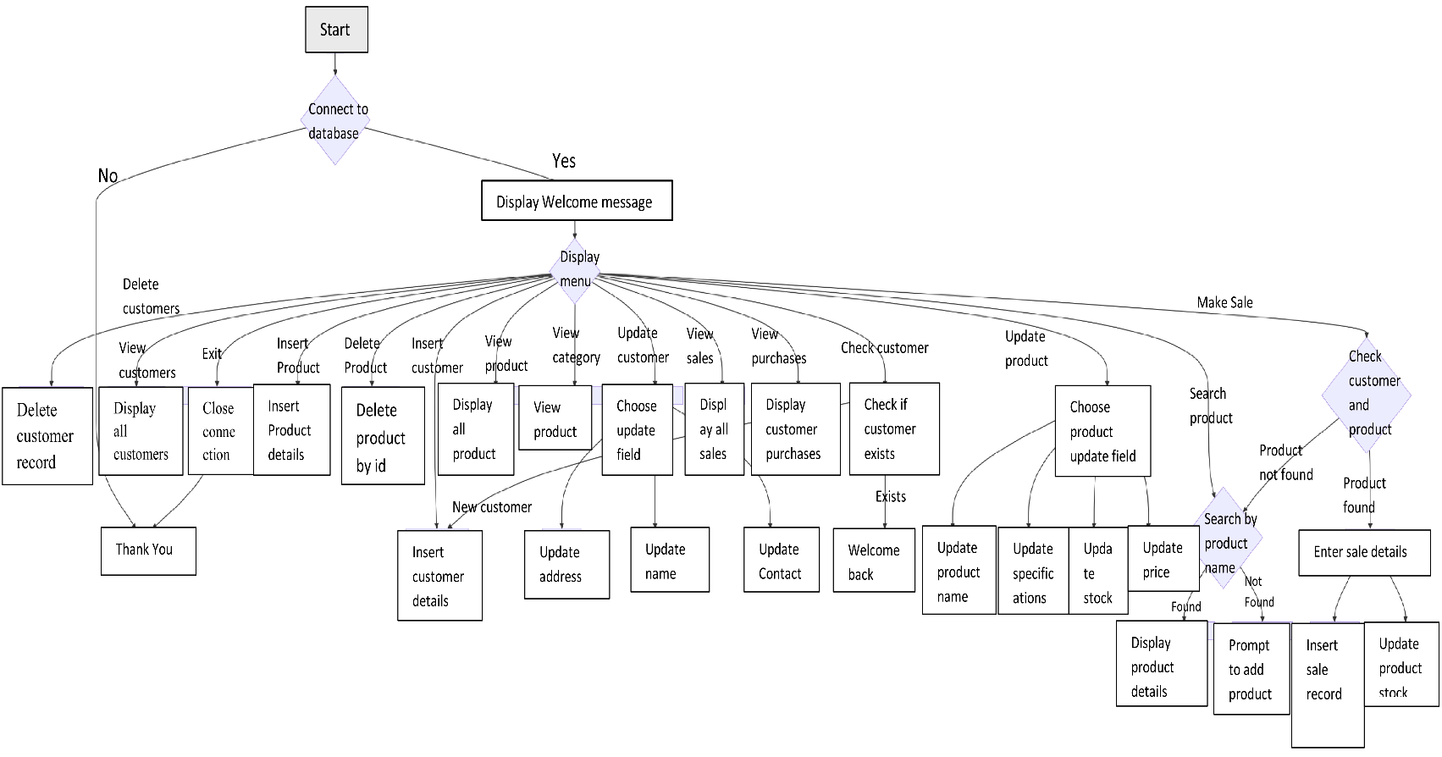

PROJECT CODE

import mysql.connector as sqltor
# Establish connection to the database
con = sqltor.connect(
host="localhost",
user="group",
password="G#n6Hg59",
database="Computer_Sales_System")

if con.is_connected():
print("||-------->>Connection successfully established<<--------||\n")
print("<>-<>-<>-Welcome to Computer and Accessories Sales Management System-<>-<>-<>")
cursor = con.cursor()
# Creating table customers
# cursor.execute("CREATE TABLE customer(c_id INT PRIMARY KEY AUTO_INCREMENT, Name VARCHAR(40), Contact VARCHAR(15), Address VARCHAR(255)) AUTO_INCREMENT = 10001")
# print("Table CUSTOMER created successfully.")
# Creating table products
# cursor.execute("CREATE TABLE products (p_id INT PRIMARY KEY AUTO_INCREMENT, Category VARCHAR(100), Name VARCHAR(500), Specifications VARCHAR(1000), Stock INT, Price FLOAT) AUTO_INCREMENT = 51029")
# print("Table PRODUCTS created successfully.")
# Creating table Sales
# cursor.execute("CREATE TABLE Sales (Customer_ID INT PRIMARY KEY, Customer_Name VARCHAR(255), Product_ID INT, Product_Name VARCHAR(255), Price_of_1 FLOAT, Quantity INT, Total_Amount FLOAT)")
# print("Table SALES created successfully.")
def insert_customer(): # Insert details of customer
while True:
name = input("\nEnter customer's name: ").title()
contact = input("\nEnter customer's contact number: ")
address = input("\nEnter customer's address: ")
cursor.execute("INSERT INTO CUSTOMER (Name, Contact, Address) VALUES (%s, %s, %s)",(name, contact, address))
con.commit()
print("Details inserted successfully!")
ch = input("Do you want to enter more records? (y/n): ")
if ch in 'Nn':
break
def update_customer(new_value, id_value): # Update customer details
up = int(input("What do you want to update?\nEnter\n1 for updating customer's name\n2 for contact number\n3 for address\nchoice: "))
if up == 1:
query = "UPDATE CUSTOMER SET Name = %s WHERE C_ID = %s;"
elif up == 2:
query = "UPDATE CUSTOMER SET Contact = %s WHERE C_ID = %s;"
elif up == 3:
query = "UPDATE CUSTOMER SET Address = %s WHERE C_ID = %s;"
else:
print("Invalid option!")
return
cursor.execute(query, (new_value, id_value))
con.commit()
print("Details updated successfully!")

def insprod(): # Insert data to table product
while True:
cat=input("\nEnter Product Category: ").title()
pname = input("\nEnter Name of the Product: ")
specs = input("\nEnter Specifications of the above product (separated by commas): ").title()
stock = int(input("\nHow many Stocks of the above product are left?: "))
price = float(input("\nEnter the Price of the above product: ₹ "))
cursor.execute("INSERT INTO PRODUCTS (Category, Name, Specifications, Stock, Price) VALUES (%s, %s, %s, %s, %s)",
(cat, pname, specs, stock, price))
con.commit()
print("Data inserted successfully!")
ch = input("Do you want to enter more records? (y/n): ")
if ch in 'Nn':
break

def delprod(pid): # Delete product record
cursor.execute("DELETE FROM PRODUCTS WHERE P_ID = %s", (pid,))
con.commit()
if cursor.rowcount > 0:
print(f"Product with P_ID {pid} deleted successfully.")
else:
print(f"No product found with P_ID {pid}.")

def delete_customer(id_value): # Delete customer record
query = "DELETE FROM CUSTOMER WHERE C_ID = %s"
cursor.execute(query, (id_value,))
con.commit()
print("Record deleted successfully.")

def view_customer(): # Display table customer
query = "SELECT * FROM CUSTOMER"
cursor.execute(query)
results = cursor.fetchall()
print("-------------------------------CUSTOMER-------------------------------")
print(f"{'C_ID':<10} {'Name':<40} {'Contact':<15} {'Address':<40}")
print()
for row in results:
print(f"{row[0]:<10} {row[1]:<40} {row[2]:<15} {row[3]:<40}")

def search_by_product_name():
n = input("Enter name of the Product to be searched: ")
cursor.execute("SELECT Name FROM PRODUCTS WHERE Name = %s", (n,))
result = cursor.fetchone()
if result is not None:
print("Found!\n")
cursor.execute("SELECT * FROM PRODUCTS WHERE Name = %s", (n,))
results = cursor.fetchall()
print(f"{'P_ID':<10} {'Name':<40} {'Specifications':<80} {'Stock':<10} {'Price (₹)':<10}")
for row in results:
print(f"{row[0]:<10} {row[1]:<40} {row[2]:<80} {row[3]:<10} {row[4]:<10}")
return True
else:
print("\nSorry, NOT Found..")
return False
def check_customer_exists(cname):
try:
query = "SELECT 1 FROM Customer WHERE Name = %s"
cursor.execute(query, (cname,))
result=cursor.fetchone()
if result is None:
print("New Customer?..Adding to Database.")
insert_customer()
else:
print("Welcome Back!")
except sqltor.Error as e:
print(f"Database error: {e}")
return False
def view_products(): # Display table products
cursor.execute("SELECT * FROM PRODUCTS")
results = cursor.fetchall()
print("-------------------------------PRODUCTS-------------------------------")
print(f"{'P_ID':<10} {'Name':<40} {'Specifications':<80} {'Stock':<10} {'Price (₹)':<10}")
print()
for row in results:
print(f"{row[0]:<10} {row[1]:<40} {row[2]:<80} {row[3]:<10} {row[4]:<10}")
def category_view():
c = input("Enter Category (Laptop/Desktop/Processor, etc.): ").title()
cursor.execute("SELECT * FROM PRODUCTS WHERE Category = %s", (c,))
results = cursor.fetchall() # Fetch all results
if results: # Check if results is not empty
print(f"\n------------------------------- {c}s -------------------------------")
print(f"{'P_ID':<10} {'Category':<30} {'Name':<25} {'Specifications':<70} {'Stock':<7} {'Price (₹)':<10}")
print()
for row in results:
print(f"{row[0]:<10} {row[1]:<30} {row[2]:<25} {row[3]:<70} {row[4]:<7} {row[5]:<10}")
return True # Products were found, return True
else:
print(f"\nNo products found in the '{c}' category.")
return False

def check_product_stock(p_id, quantity):
try:
query = "SELECT stock FROM products WHERE p_id = ? LIMIT 1;"
cursor.execute(query, (p_id,))
result = cursor.fetchone()
if result is not None:
available_stock = result[0]
if available_stock >= quantity:
return True
else:
print("Insufficient stock!")
return False
else:
print("Product not found!")
return False
except sqltor.Error as e:
print(f"Database error: {e}")
return False
def view_sales(): # Display table SALES
query = "SELECT * FROM SALES"
cursor.execute(query)
results = cursor.fetchall()
print("-------------------------------SALES-------------------------------")
print(f"{'Customer_ID':<10} {'Customer_NAME':<40} {'Product_ID':<10} {'Product_Name':<40} {'Price(1)':<10} {'Quantity':<15} {'Total_Amount(₹)':<10}")
print()
for row in results:
print(f"{row[0]:<10} {row[1]:<40} {row[2]:<10} {row[3]:<40} {row[4]:<10} {row[5]:<15} {row[6]:<10}")

i = 1
while i != 12:
print("\n1. Insert Data into table Customer.\n2. Delete Data from table Customer.")
print("3. Update Data of table Customer.\n4. View Data of table Customer.")
print("\n5. Insert Data into table Products\n6. Delete Data from table Products.")
print("7. Update Data of table Products.\n8. View Data of table Products.\n9. View Products by Category.")
print("\n10. Make Sale.\n11. View Sales.\n\n12. Exit")
i = int(input("Enter choice (1/2/3/4/5/6/7/8/9/10/11/12): "))
if i == 1:
insert_customer()
elif i == 2:
id_value2 = int(input("Enter customer ID of customer whose details are to be deleted: "))
delete_customer(id_value2)
elif i == 3:
id_value1 = int(input("Enter customer ID of customer whose details are to be updated: ")).title()
new_value = input("Enter the value to be updated: ").title()
update_customer(new_value, id_value1)
elif i == 4:
view_customer()
elif i == 5:
insprod()
elif i == 6:
p_id = int(input("\n\nEnter Product ID: "))
delprod(p_id)
elif i == 7:
p_id = int(input("\n\nEnter Product ID: "))
print("Update\n1. Name of the Product\n2. Specifications of Product\n3. Stock of Product\n4. Price of Product")
c = int(input("Enter choice (1/2/3/4): "))
if c == 1:
n = input("\nEnter new Name of the product: ").title()
cursor.execute("UPDATE PRODUCTS SET Name = %s WHERE P_ID = %s", (n, p_id))
con.commit()
print("Name updated successfully!")
elif c == 2:
s = input("\nEnter new Specifications of the product: ")
cursor.execute("UPDATE PRODUCTS SET Specifications = %s WHERE P_ID = %s", (s, p_id))
con.commit()
print("Specifications updated successfully!")
elif c == 3:
st = int(input("\nEnter new Stock number of the product: "))
cursor.execute("UPDATE PRODUCTS SET Stock = %s WHERE P_ID = %s", (st, p_id))
con.commit()
print("Stock Number updated successfully!")
elif c == 4:
p = float(input("\nEnter new Price of the product: ₹ "))
cursor.execute("UPDATE PRODUCTS SET Price = %s WHERE P_ID = %s", (p, p_id))
con.commit()
print("Price updated successfully!")
elif i == 8:
view_products()
elif i == 9:
category_view()
elif i == 10:

cn = input("Enter Customer Name: ").title()
check_customer_exists(cn)
c12=int(input("1. Search Product by Name\n2. View Products by Category\nChoice (1/2): "))
chk=0
if c12==1:
if search_by_product_name()==True:
chk=1
elif c12==2:
if category_view()==True:
chk=1
if chk==1:
pid1=int(input("Enter Product ID (from table above): "))
quan=int(input("Quantity: "))
if check_product_stock(pid1,quan)==True:
cursor.execute("SELECT c_id, name FROM Customer WHERE name = %s", (cn,))
cust = cursor.fetchone()
cursor.execute("SELECT p_id, name, price FROM Products WHERE p_id = %s", (pid1,))
prod = cursor.fetchone()
if cust and prod:
total_amt = quan * prod[2]
cursor.execute("INSERT INTO Sales (Customer_ID, Customer_Name, Product_ID, Product_Name, Price_of_1, Quantity, Total_Amount) VALUES (%s,%s,%s,%s,%s,%s,%s)", (cust[0], cust[1], prod[0], prod[1],prod[2], quan, total_amt))
con.commit()
print("Data successfully inserted into the Sales table.")
cursor.execute("UPDATE Products SET Stock = Stock - %s WHERE p_id = %s", (quan, prod[0]))
con.commit()
else:
print("Customer or Product not found.")
else:
print("purchase can't be made...retry with lesser quantity!")
else:
print("Product Not Found!")
elif i == 11:
view_sales()
elif i == 12:
cursor.close()
con.close()
print("Exited successfully.\nTHANK YOU")
input("\nPress Enter to proceed...")
else:
print("CONNECTION UNSUCCESSFUL!")
SCREENSHOTS OF OUTPUT
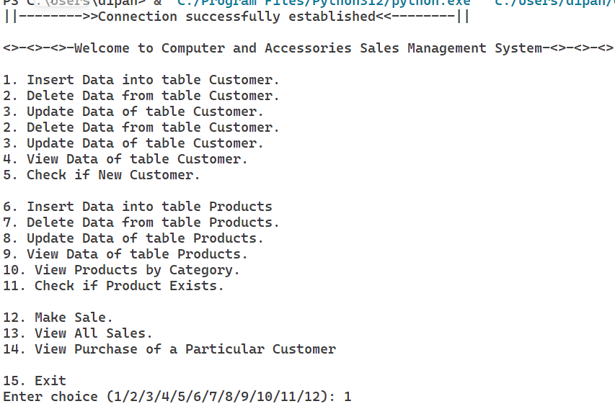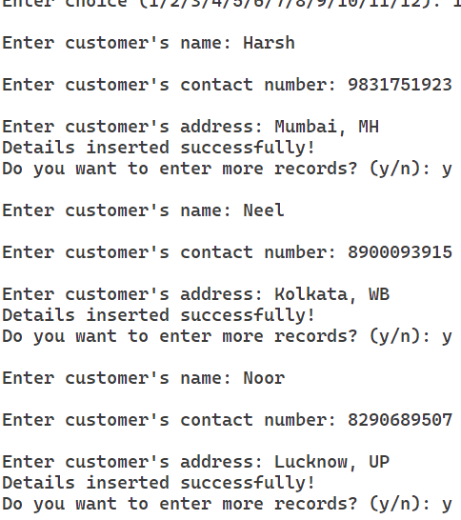
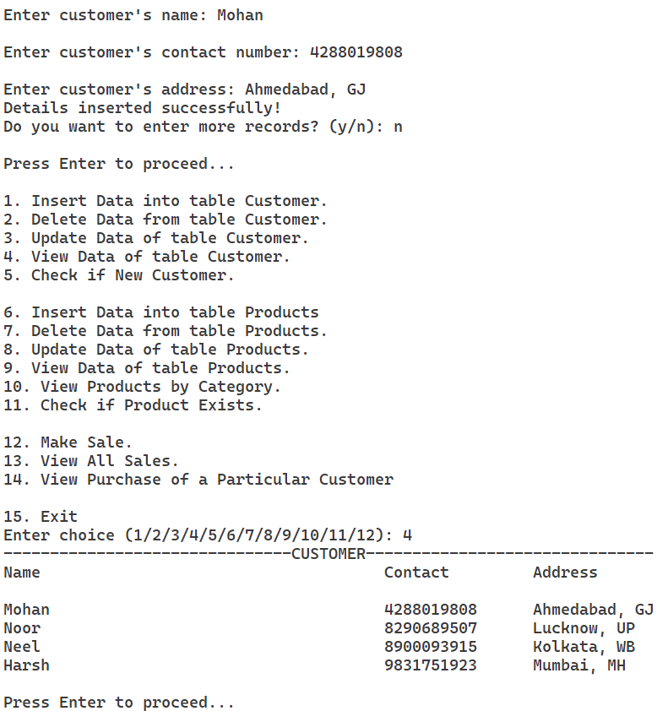
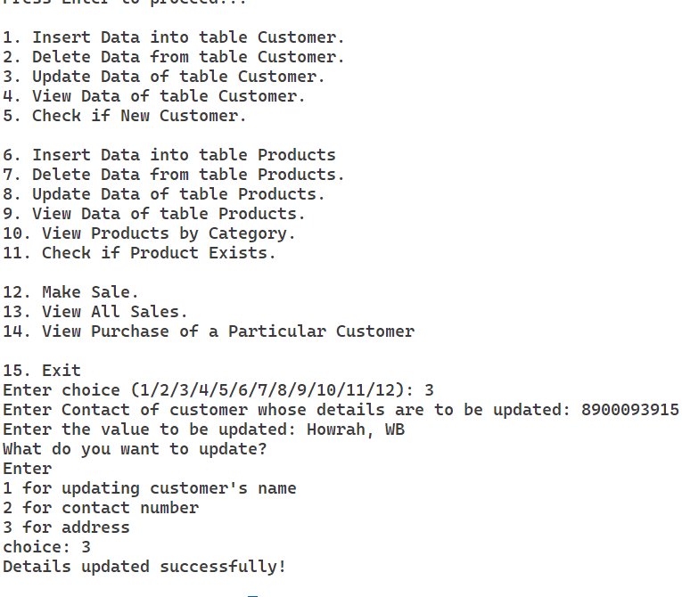
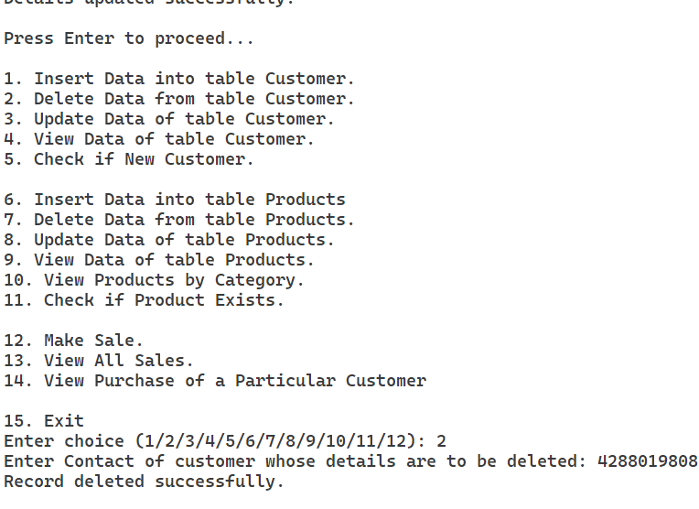

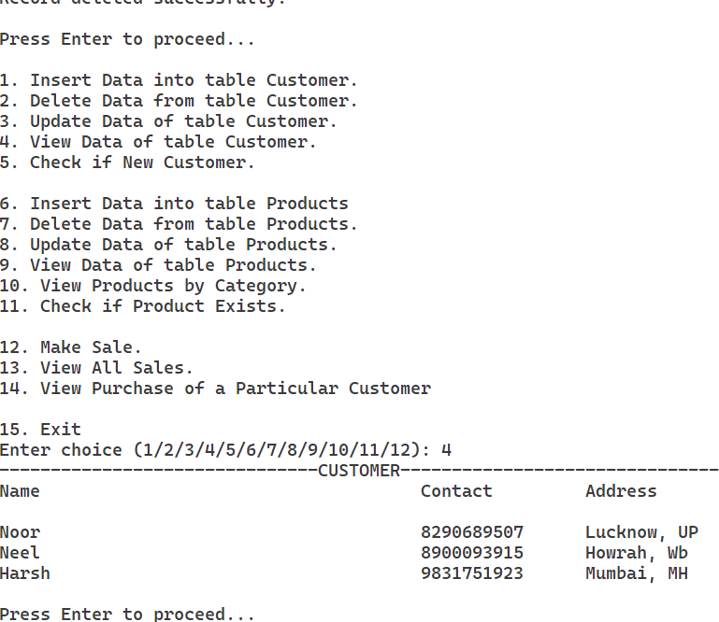

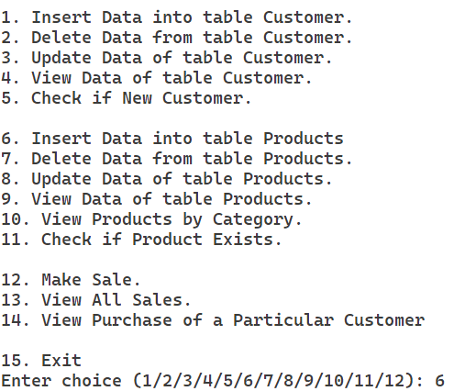
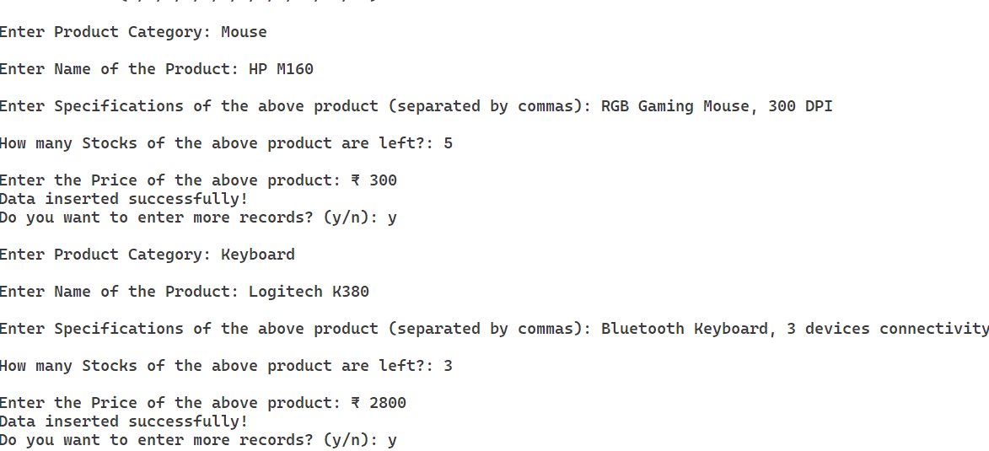
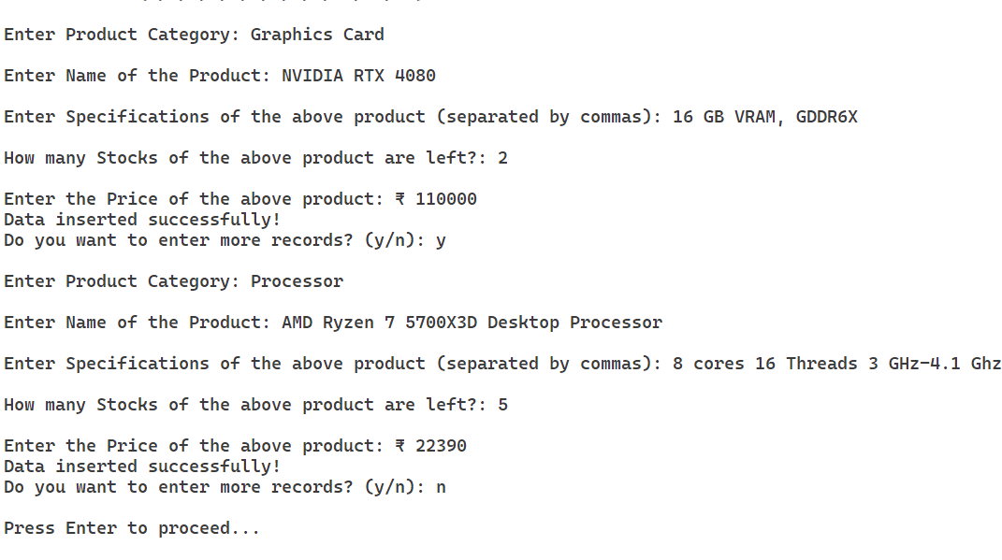

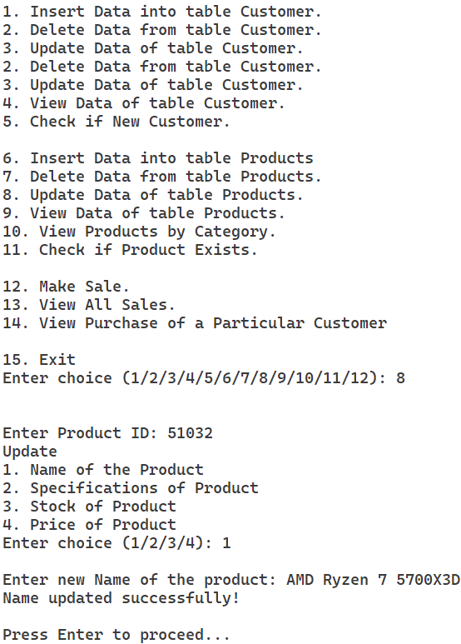

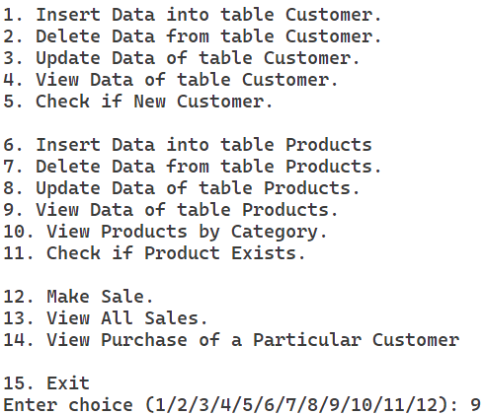

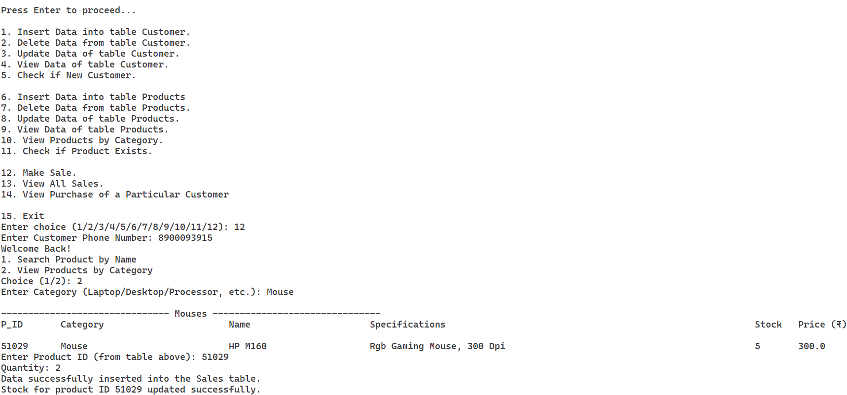
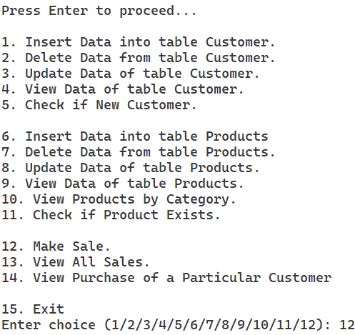

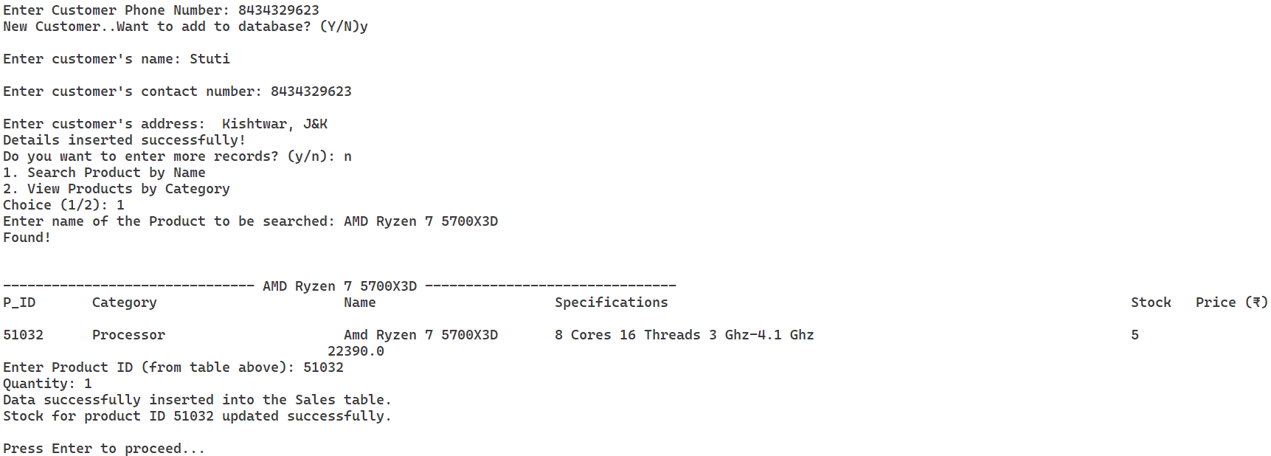
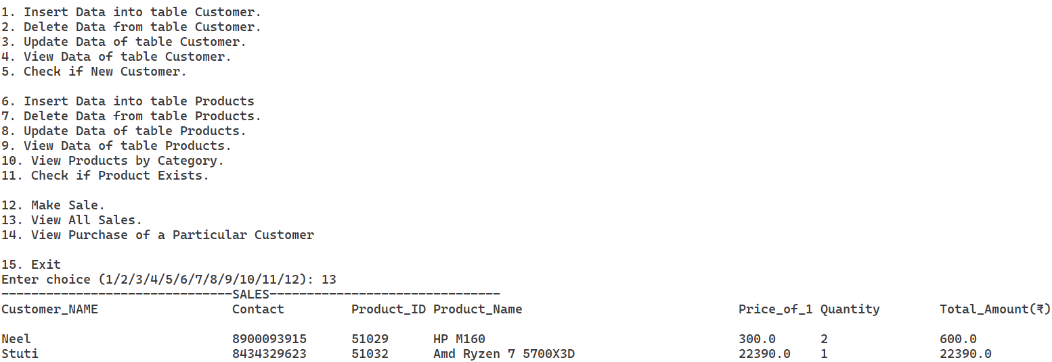
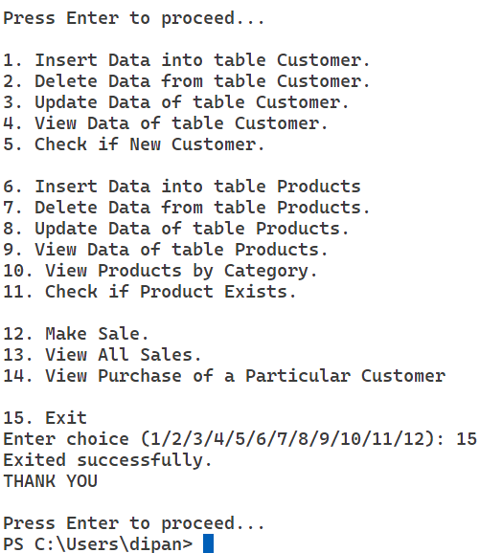

SCREENSHOTS OF DATABASE

- Table Customer

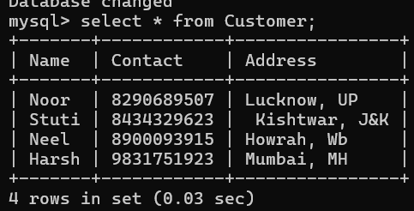

- Table Products

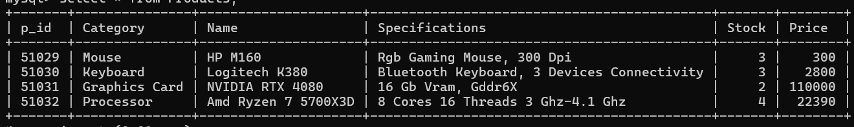

- Table Sales

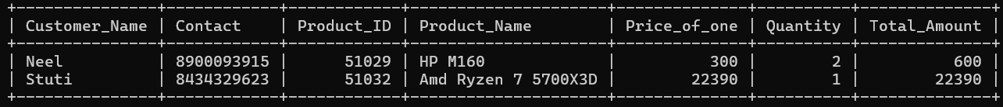

LIMITATIONS

- Scalability: The system may not be designed to handle a high volume of concurrent users or large datasets effectively.

- Security: Basic security features such as user authentication and encrypted connections might be missing, posing risks of unauthorized access.

- User Interface: The project may only include a simple user interface, focusing primarily on backend operations.

- Error Handling: Limited error handling and data validation could lead to data integrity issues if improper input is entered.

- Advanced Features: The system may not support advanced features like automated stock management or real-time updates.

- Reporting Capabilities: The project may only include basic sales viewing features without comprehensive reporting or analytics tools

- Backup and Recovery: A robust backup and recovery mechanism may be absent, risking data loss in case of failures.

BIBLIOGRAPHY

- https://www.python.org/

- MySQL Documentation: The MySQL documentation was referenced for understanding MySQL query syntax, creating tables, using primary keys and auto-increment properties in SQL. Available at: https://www.mysql.com/

- Python MySQL Connector Library Documentation: This documentation provided details on using the mysql.connector library to connect Python applications with MySQL databases, as well as using functions like cursor.execute and con.commit. Available at: https://dev.mysql.com/doc/connector-python/en/

- Python Programming Textbook: Concepts such as error handling with try-except, user input handling, and function definitions were developed using foundational knowledge from Python programming textbooks, such Computer Science Textbook for Class XII by NCERT. https://ncert.nic.in/

